**Git Branching**

Having a branching strategy is necessary to avoid conflicts when merging and to allow for the easier integration of changes.

The main idea behind the Git branching strategy is to isolate your work into different types of branches.

The branching strategy consists of the following branches:

* Master – Main code of the repository
* Develop – Copy of master but can be developed with new requirements and must be merged back to master.
* Feature - to develop new features that branches off from develop or QA/test branches
* Release - help prepare a new production release; usually branched from the develop branch and must be merged back to both develop and master
* Hotfix - also helps prepare for a release but unlike release branches, hotfix branches arise from a bug that has been discovered and must be resolved; it enables developers to keep working on their own changes on the develop branch while the bug is being fixed.

Branching Strategy

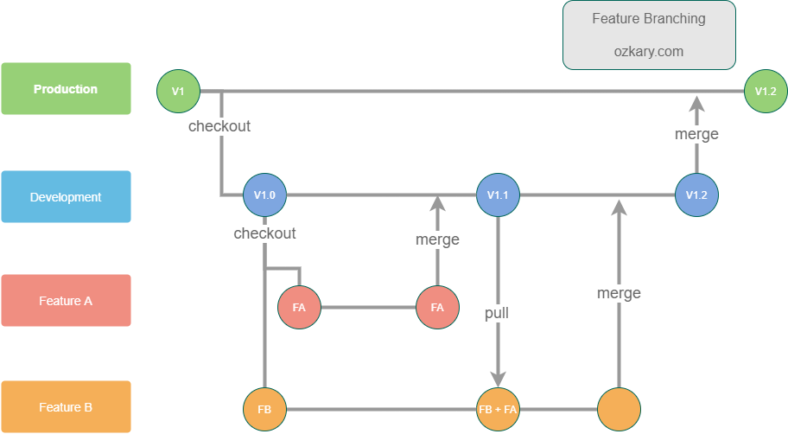

Master